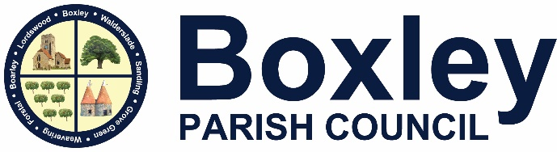

Street Parking Policy

This policy sets out the Parish Council’s response to frequently reported resident parking problems.

Parking on Verges

The parish council, whilst appreciating the damage that can be caused by cars parking on highway verges and the inconsiderate parking by a few residents, nevertheless recognises that in residential areas there is often a lack of available parking for the number of cars owned by residents. On narrow roads vehicles are often bumped up onto the kerb to allow other vehicles and emergency vehicles to pass but this can cause problems for people using the adjacent footway. The parish council recognises that sufficient space must be left on the footways for pushchairs, mobility scooters etc.

Direct action e.g. paying for bollards to be installed, will only be considered if there is an obvious health and safety risk to pedestrians or other road users or there is a persistent problem with sufficient parking provision in the area.

Requests for Yellow Lines

The parish council will support requests for yellow lines at junctions where they are needed to ensure that the vision splay is sufficient to allow pedestrians to cross safely and for cars to exit safely.

What the Parish Council will do

1. The parish council will work with residents to help highlight problems to the relevant authorities and to try to identify alternative arrangements to alleviate the problems being experienced.

2. Contacting companies, if it is a company vehicle, to ask that they speak to the driver and ask them to park elsewhere.

3. Writing to residents who persistently park in what is perceived as an antisocial way or by placing an advisory note on the windscreen of the vehicle.

4. Notifying KCC, MBC and the PCSO to see if their help can be obtained.

The parish council reserves the right to amend its approach after considering the merits of each individual situation.

Requests for intervention where there is no health and safety risk will not be considered if the result would be the problem is just moved elsewhere.

Adopted April 2026

